

## To: Council

## Date: 16 February 2023

## Report of: Head of Financial Services

## Title of Report: Chief Finance Officer’s report on the robustness of the Council’s 2023/24 budget

Summary and Recommendations

Purpose of report:

Under Section 25 of the Local Government Act 2003 there is a requirement for the Council’s Chief Financial Officer to report to Council on:

a) the robustness of the estimates made for the purposes of the calculations of the budget; and

b) the adequacy of the proposed financial reserves.

Council in considering its Budget should have regard to this advice.

Recommendation: That Council notes this report in setting its budget for 2023/24 and the indicative budgets for 2024/25 – 2026/27.

Appendix A: Statement of Reserves and Balances

**Introduction**

1. As the adverse impact of COVID 19 subsides, the country begins to return to some sense of normality. Over the last few years businesses have been significantly impacted financially and some unfortunately have become insolvent. The extension of the business rates relief scheme for 2023-24 and an increase in relief from 50% to 75% announced in the Finance Settlement may offer those businesses in the retail, hospitality and retail sector some respite and hopefully allow more time for footfall to improve and improve their financial position.
2. The knock on effect to the city and the Council has similarly created financial pressures which although show some signs of improving, still leaves legacy debts to deal with and an element of uncertainty about the future. The COVID related grants given to local government unfortunately have not been sufficient to avoid the need to dig deep into council reserves and although it has enabled the council to ‘ride out the storm’, the depletion of such reserves has reduced the council’s resilience to deal with the uncertainties going forward.
3. This report to Council is a statutory requirement of the Councils Chief Financial Officer under Section 25 of the Local Government Act 2003, to report to Council on :
4. The robustness of estimates made for the calculation of the budget
5. The adequacy of reserves

4 Council are required to consider this report alongside the budget setting discussions.

# Preparation of the Medium Term Financial Plan

1. As in previous years the Council has undertaken a prudent and robust approach in developing its Medium Term Financial Strategy (“MTFS”) based on information that is available to date and prudent forecasts of the income and expenditure that will be arise whilst undertaking it’s services.

**Robustness of Estimates**

* + - 1. All aspects of the Council’s budget, efficiency savings, additional income streams, and pressures have been subject to rigorous review, with Service Heads being required to review the plans they put forward in previous years and confirm delivery of the proposals over the life of the MTFS.
      2. Scrutiny of the budget has been undertaken by
* The Finance Team
* Directors and the Chief Executive
* Executive Members
* The Scrutiny Committee’s Finance Panel

1. Monitoring of the budget through the year is undertaken by Financial Services in conjunction with Heads of Service and Cost Centre Managers to ensure that the budget is on target or variations are reported and acted upon at an early stage. Monthly monitoring reports are considered by Heads of Service at the Council’s Operational Delivery Group and Corporate Management Team with quarterly updates presented to Cabinet.
2. The Council has established a Project Management Office to oversee and undertake project management of projects within the Council’s Capital Programme. Potential projects are subject to more rigour and resources are spent on establishing the feasibility and outline business case before a bid is made through Cabinet and Council for budget approval of funds to carry out the project.

# General Fund Assumptions

1. Assumptions on which the four year MTFS are based are contained within the main budget report presented elsewhere on the agenda, however, the key assumptions include:

* **Council Tax increase**- The assumed Council Tax increase is 2.99% per annum for 2023-24 and 2024-25 with 1.99% thereafter. This is below the referendum level for 2023/24.
* **Income Streams** – income streams especially those susceptible to reduction from COVID related issues have been budgeted prudently. Car parking income is unlikely to return to pre Covid levels in 2023-24. Town Hall income from lettings is forecast to return to normal levels. Commercial rent income arrears stand at around £7millon for which a provision has been made to cover. The material part of this outstanding debt arose over the period of the pandemic when he Council were prevented from taking enforcement action. With the addition of a number of key property related projects, base commercial rent income is beginning to increase.
* **Investment Interest** – The Bank of England raised base rates to 3.5% and although this is not yet at its peak thought to be around 4.5% rates are expected to fall back in 2024 settling back at around 2.5%.
* **OxWed Development** – Income yield from the councils partnership in Oxwed LLP continues at 6.5% on the amount invested which currently stands at £12.6 million. Planning approval is under consideration and alongside it the delivery strategy which will move the project closer to the delivery of financial returns to the Council and its partner Nuffield College.
* **Oxford Direct Services Ltd -** The updated ODS Business Plan includes ambitious targets to generate additional turnover for the companies trading arm ultimately improved dividend return to the Council. Profit after tax is estimated at around £5.4 million by 2025-26.
* **Oxford City Housing Ltd** –Dividend returns from the Company are expected to be around £13.5 million over the MTFS.
* **Borrowing –** The Councils Capital Finance Requirement (CFR) representing the underlying need to borrow to finance the capital programme over the MTFS will increase from £479 million to around £796m (HRA £596/ General Fund £199m). External debt will increase from £364 million to around £683 million over the same period. A provision has been made within the General Fund and the HRA for financing costs including the Minimum Revenue Provision (MRP) in accordance with the Councils MRP policy.
* **Retained Business Rates** – The MTFS includes estimates of the amount of Retained Business Rates income for the authority, based on the Government’s indication of tariffs and baseline income for 2023-24. The Government have indicated that fairer funding and business rates reset will be delayed until 2025-26 at the earliest. There remains uncertainty after this date for which a provision has been built into the MTFS.
* **Pay Assumptions** – The current two year pay deal expires on 31-3-2024. Inflationary rises have been allowed for in the MTFS going forward
* **Inflation** – With the exception of contractual inflation e.g. Leisure contract and ICT maintenance contracts and pay budgets all other budgets are cash limited.
* **Contingencies and Provisions** - Contingencies have been provided for at around £600k per annum. This is deemed to be adequate to cushion the revenue account against potential shortfalls in efficiency savings and additional income as well as shortfalls in returns from the Councils wholly owned companies arising from non-performance.

# Housing Revenue Account (HRA) Assumptions

1. The Scrutiny of the HRA budget and Business Plan has followed a similar process to that for the General Fund outlined above.
2. Key assumptions in the HRA budget include:

* **Rent Setting**

Government policy for the 5 year period commencing 1-4-2020 has been for rent increases to be no more that CPI +1%. For 2023-24 following a consultation exercise the Government limited the rent rise to 7% with assumptions for the following years being based on CPI.

* **Debt Management Strategy**

Debt will rise from an estimated £309 million in 2022-23 to peak debt of £636 million in 2030-31 largely from accommodating the purchase of affordable housing from the Housing Company. Sufficient provision has been made in the HRA to cover the cost of this debt.

* **Inflation and pay assumptions**

All the assumptions for pay inflation are the same as for the Council’s General Fund.

# Capital

1. The Council has set an ambitious Capital Programme for the next four years in excess of £767 million.
2. The preparation of the Capital Programme has undergone similar scrutiny to the other areas of the Council’s budget with the Development Board having an oversight of all new bids. Contingencies are included within individual schemes for variations in spend with any other variations outside these amounts being subject to the normal virement and supplementary estimate approvals set out in the Council’s Financial Rules.
3. Financing of schemes within the Programme is predominantly through borrowing which at £502 million over the 4 year programme represents 66% of the total programme. Most General Fund additional borrowing is in relation to loans to the Council’s Housing Development Company (OCH(D)L) with the HRA borrowing being in relation to the purchase of social housing units from OCH(D)L. Whilst this represents a significant increase in Council debt to over £0.6 billion by 2030-31 and the associated revenue implications have been accounted for in the MTFS and the debt is manageable.

# Adequacy of Reserves and Balances

1. The prudent level of reserves that the Council should maintain is a matter of judgement. Generally the higher the risk of the council’s financial plans the higher the level of reserves and balances. The Oxford Model’s reliance on income streams from its wholly owned companies and other sources of income such as commercial rents (as illustrated below) is more of a risk than simply reducing spend. In such situations it is prudent and advisable to hold an adequate amount of reserves and balances to deal with any volatility in these areas.

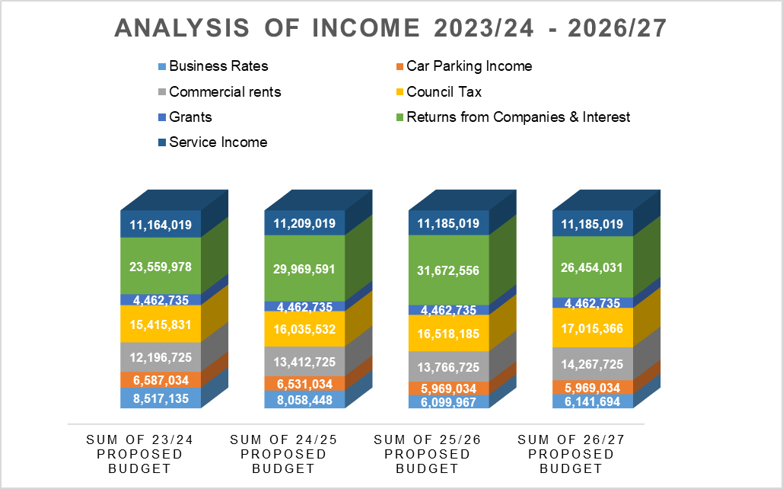

1. The level of the Councils overall reserves and balances is shown in Appendix 1 and summarised in Table 1 below:



**Notes**

* Ring fenced accounts funded by third parties which must be repaid if not used for the purpose specified, e.g. Salix Funds and Section 106 commuted sums
* Other ring fenced accounts -reserves which have a statutory limitation on their use; such as the Taxi Licensing Reserve, grants reserved and the HMO Licensing Reserve
* Other earmarked reserves which have been earmarked but are largely unspent
* Accounts which it is considered prudent to set aside for a specific purpose such as the Insurance Fund
* Working balances – are funds which are not ringfenced for any purpose

1. Table 1 indicates that General Fund earmarked reserves and balances will reduce from £55 million at 31-3-2022 to an estimated level at 31-3-2023 of £45 million and then to an estimated £42 million by 31-3-2024. Other points worthy of note :

* **Ringfenced reserves** relating to grants, licenses, HMO, Salix and Commuted sums can only be used for the specific purposes.
* **Unringfenced earmarked reserves** that although allocated can be used to cover General Fund Revenue deficits are estimated to reduce to around £17 million by 31st March 2023 i.e. a 35% reduction compared to the estimated position at 31-3-2022.
* **The COVID Emergency Reserve** (number 68) will reduce from 7.4 million at 31-3-2022 to around £5.4 million as at 31-3-2023 and then to £4 million.
* The Councils General Fund working balance remains at around £3.8 million throughout the period of the MTFS
* The HRA working balance is estimated at around £4 m representing around 8% of gross rental income, sufficient to meet any unexpected financial issues that may arise.

# Financial Resilience

1. The consequence of not keeping a prudent level of reserves can be significant. In the event of a serious problem, or a series of events such as a downturn in the financial position of ODS, reduced activity in OCHL or a reduction in the value of the Council’s property investments it could lead to less return for the Council and potentially a deficit position. In the absence of reserves the Council would be forced to cut expenditure in a damaging or arbitrary way.
2. The Chartered Institute of Public and Finance and Accountancy (CIPFA) has stated that there should be no imposed limit on the level or nature of balances required to be held by an individual Council. However, for a district council, where changes to a few areas can have a disproportionate impact, a higher percentage of level of reserves to net expenditure is desirable. The level of balances to be held is largely a matter of judgement for the Councils Section 151 Officer based on local circumstances such as the level of activity in the council, the risk appetite of the council, the council’s reliance on income streams and gross expenditure.
3. CIPFA undertake a survey of councils to understand their financial resilience. By analysing data from individual councils and providing comparisons on a number of key financial areas, CIPFA place a risk rating against each of these measures in terms high, medium and low risk. The latest exercise was undertaken in December 2022 based on financial information for 2021-22.
4. The main observations in comparison to other non-metropolitan districts was as follows:

* The ratio of Council tax income as a proportion of net expenditure was 38% for Oxford against a range of 34%- 100% for other local authorities. The authority was deemed low risk, which is surprising.
* The ‘Oxford Model’ relies on significant income streams to fund its gross expenditure. Fees and charges as a ratio to service expenditure is 25% against a range of 1.37% to 57% for other local authorities. This ratio will increase over the life of the MTFP given the reliance on financial returns from OCHL and ODS and although deemed low by CIPFA is certainly one to closely monitor.
* The high percentage of business rates growth above baseline for Oxford City Council at 74% within a range of -153% to 435% is reflective of the opening of the Westgate Shopping Centre and is deemed medium to high risk.
* At £3.8 million the General Fund Working Balance at around 10% of net revenue expenditure. Whilst this was far short of the upper end of the sample group at 300% and is considered high risk, it is still considered by the Council’s Section 151 Officer to be a reasonable level for this authority especially when combined with earmarked reserves.

**Sensitivity Analysis**

1. Risks remain around fluctuations in the council’s incomes and expenditure. Whilst it is unlikely that there would an adverse impact on all of these areas all at once should this happen then reserves would be required to cover the resultant shortfall. The following analysis indicates the financial impact of a 10% variation on significant items of income and expenditure.

|  |  |  |
| --- | --- | --- |
|  |  |  |

|  |  |  |
| --- | --- | --- |
| **10% Variation in Income And Expenditure** | | |
|  | **Gross**  £000's | **Risk**  £000's |
| Additional efficiencies | 410 | 41 |
| Car Parking Income | 6,595 | 660 |
| Commercial rent income | 11,634 | 1163 |
| Dividend from ODS | 1,633 | 163 |
| Business Rates | 8,517 | 852 |
| Returns from OCHL | 2,311 | 231 |
| Other investment interest | 1,367 | 137 |
| Homelessness expenditure | 5,711 | 571 |
| Planning income | 2,424 | 242 |
| **Total** | **40,602** | **4,060** |

|  |  |  |
| --- | --- | --- |
|  |  |  |

**Treasury Management**

1. Reserves and Balances are an essential part of cash balances on which the Treasury function is based. Whilst waiting to be used they will attract interest of currently around 3% per annum depending how they are invested. Longer term investments such as property funds and lending to companies including the Council’s wholly owned companies will attract interest in the region of 4.5% to 6%, while investments held for short term liquidity purposes will be at the lower end.
2. The budget for investment net interest from company lending, HRA and investments is £5 million per annum. Reserves and balances can also be ‘internally borrowed’ essentially deferring the need to borrow externally to meet capital commitments. Such borrowing is currently cheaper than accessing external borrowing sources such as the Public Works Loan Board (PWLB).

**Progress on the 2022/23 Budget**

1. Budget monitoring for the 6 months ending 31 December 2022 indicates an outurn budget deficit of around £0.700 million. If outurn remains at this figure this deficit will need to be met from reserves and balances referred to in this report.

**Conclusion**

1. I have reviewed the budget preparation process for 2023-24 to 2026-27 and the level of reserves and balances. The Council still faces significant financial challenges in a number of areas including

* **Business Rates Retention** – although the Government have confirmed that fairer funding and business rates reset have been pushed back to 2025, it is still no clearer how this will affect the authority from then onwards.
* **Pressures around income streams** especially commercial rents brought about by the COVID 19 pandemic. Prudent estimates have been made of the likely estimated position of these income streams with some such as commercial rents not considered to return to their pre COVID position for a number years.
* **The success of the council’s wholly owned companies** will be key to its financial success with returns and dividend over the MTFS of around £47 million. The performance of these companies will need to be closely monitored.
* **Transformation efficiency changes** – the Councils ambitious programme of transformation to drive out £3.3 million of ongoing efficiency savings by 2026-27 will need close monitoring to ensure delivery.

1. In relation to the HRA, there is a significant increase in borrowing to facilitate affordable housing purchases from the Council’s wholly owned company although analysis would suggest that these purchases are financially viable in terms of Internal Rate of Return, Payback and Net Present Value and following an external strategic review of the HRA Business Plan measures have been introduced to ensure that this borrowing remains affordable.
2. The level of unringfenced reserves will fall by 35% between 2022-23 and 2023-24 to amount of £17 million.
3. The Head of Financial Services had always reinforced the need for reasonable levels of reserves especially given the risks around the Oxford Model. Whilst the Oxford Model does ensure that services are maintained in the face of reductions in Government funding, it does so by using externally generated income either from services provided by the Council or from our wholly owned companies. The alternative is to reduce services and hence spend.
4. Ideally these reserves should consider topping up these reserves as a first call should surpluses in the revenue account become available, to strengthen its financial position when it can.
5. Despite the issues highlighted above the Council has undertaken a rigorous process in its budget setting for the Medium Term and more specifically I would conclude that:

* The process for the formulation of General Fund, HRA and Capital budgets, together with the level of challenge, provides a reasonable assurance of their robustness.
* The level of reserves at this stage is adequate and based on current understanding should be sufficient to cover fluctuations in income and expenditure over the medium term.

**Financial Implications**

1. These are covered within the report

# Legal Implications

1. In addition to the obligation for the Chief Finance Officer to report under Section 25 of the Local Government Act 2003 set out in the purpose of this report, the provisions of the Local Government Finance Act 1992 set out what the Council has to base its budget calculations upon, and requires the Council to set a balanced budget having regard to the advice of its chief finance officer (section 151).

# Risk Implications

1. An analysis of ‘Key Risks’ is shown in the main Budget report elsewhere on the agenda. They are key factors to take into account when determining the level of reserves that the authority should retain.

|  |  |
| --- | --- |
| **Report author** | Nigel Kennedy |
| Job title | Head of Financial Services |
| Service area or department | Finance |
| Telephone | 01865 252708 |
| e-mail | nkennedy@oxford.gov.uk |





